C++ Lab Assignment 1

1. Write a C++ Program to print the following using cout and manupulators (endl, left, right, setw)

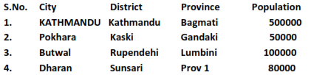

2. Write a Program defining an inline function to compute the area of circle with radius as input.

3. Write a program to get input a string and print the string and its reverse. Define your own function to reverse the string in your program.

4. Write a program overloading function sort() to sort an array of integers, characters as well as floating point numbers(Use any sorting algorithm).

5. Write a program that uses a structure Distance with data members meter and centimeter. Add functions in structure to take input and output as well as the function to add the two variables of Distance and return the sum. Your program should display the result.

6. Write program with objects as function(to add time) argument by passing by value, passing by address and passing by reference defining a class Time with data member hour, minute, second as integers. Write member functions to read the data for objects and to show the value of objects of Time.

7. Define a friend function addtime() with objects as arguments and return the sum of two objects. Show the values of each object and their sum as output.

8. Write different programs to implement passing by reference and passing by value in C++.

9. Write different programs to implement different storage classes (auto, register, extern and static) in C++ with its output.

10. Write a C++ program to illustrate dynamic allocation and de-allocation of memory using new and delete.

11. Write a program using dynamic memory allocation to get input an array of numbers and find the sum of N numbers stored in the array using a function to compute the sum.

12. Write a program to implement user defined constructor and copy constructor.

13. Write a program to illustrate constructor overloading in C++.